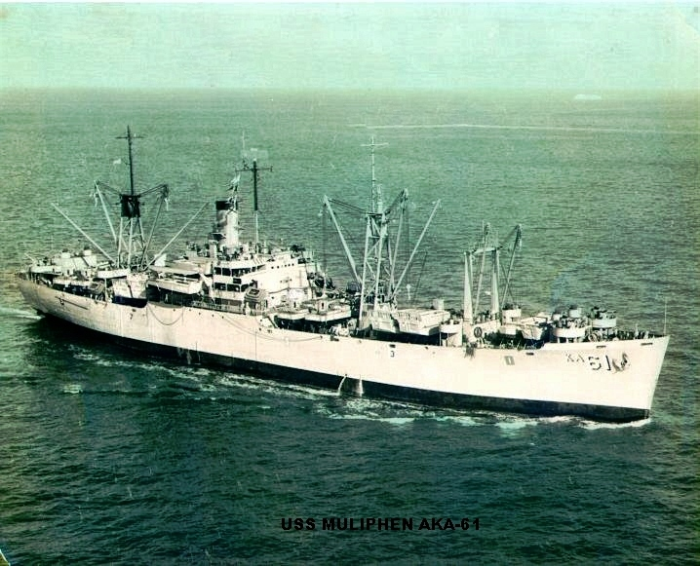
USS Muliphen AKA-61
Number 20 Vol. 1
June 2015



Greetings from the Helm:
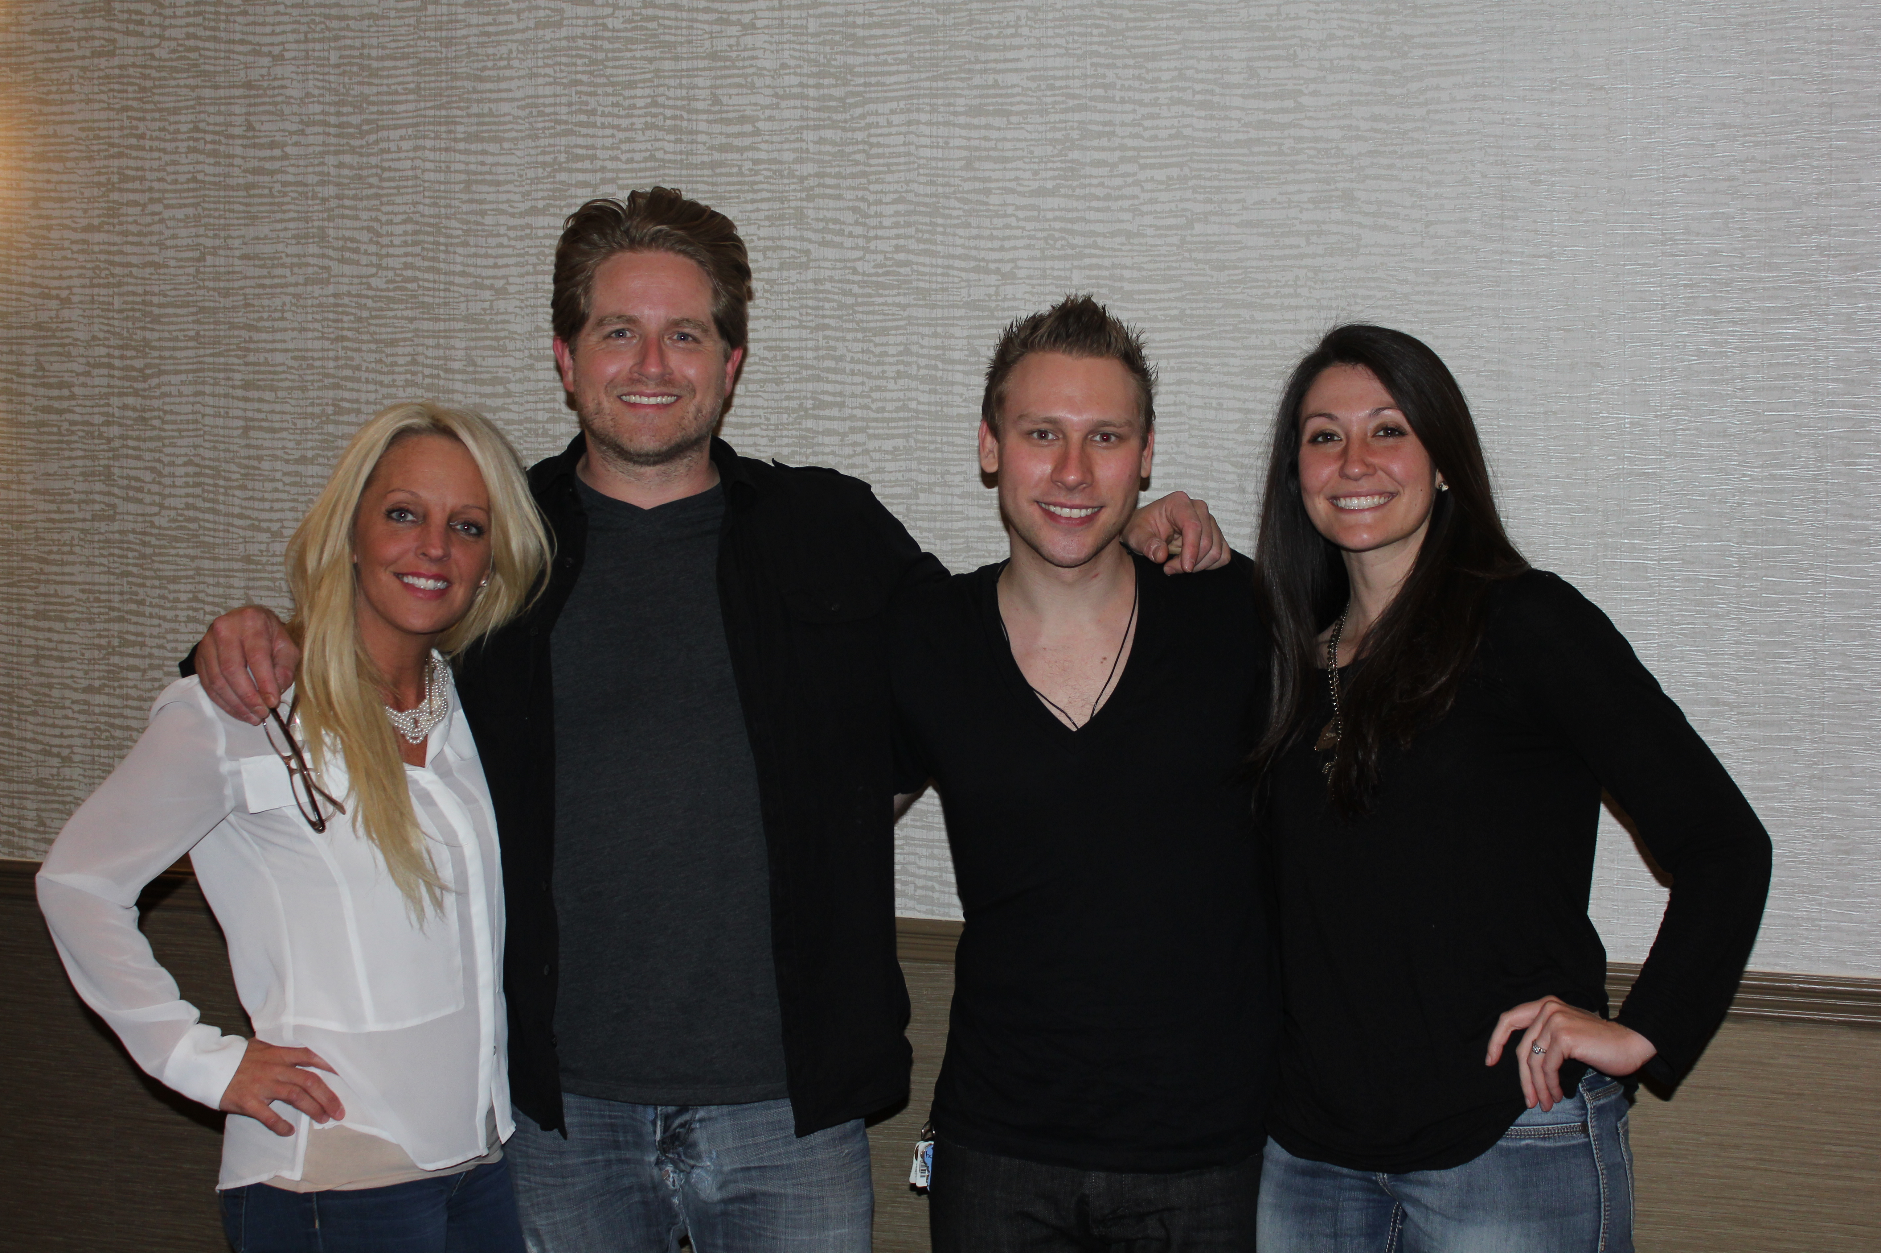
The 2015 reunion held in Nashville, was quite a success. We had live banquet entertainment, Riverboat tour, City tour and the Grand Ole Opry. A few glitches here and there with hotel rooms and hospitality room, were soon ironed out. It was great to see everyone again and their guest too.
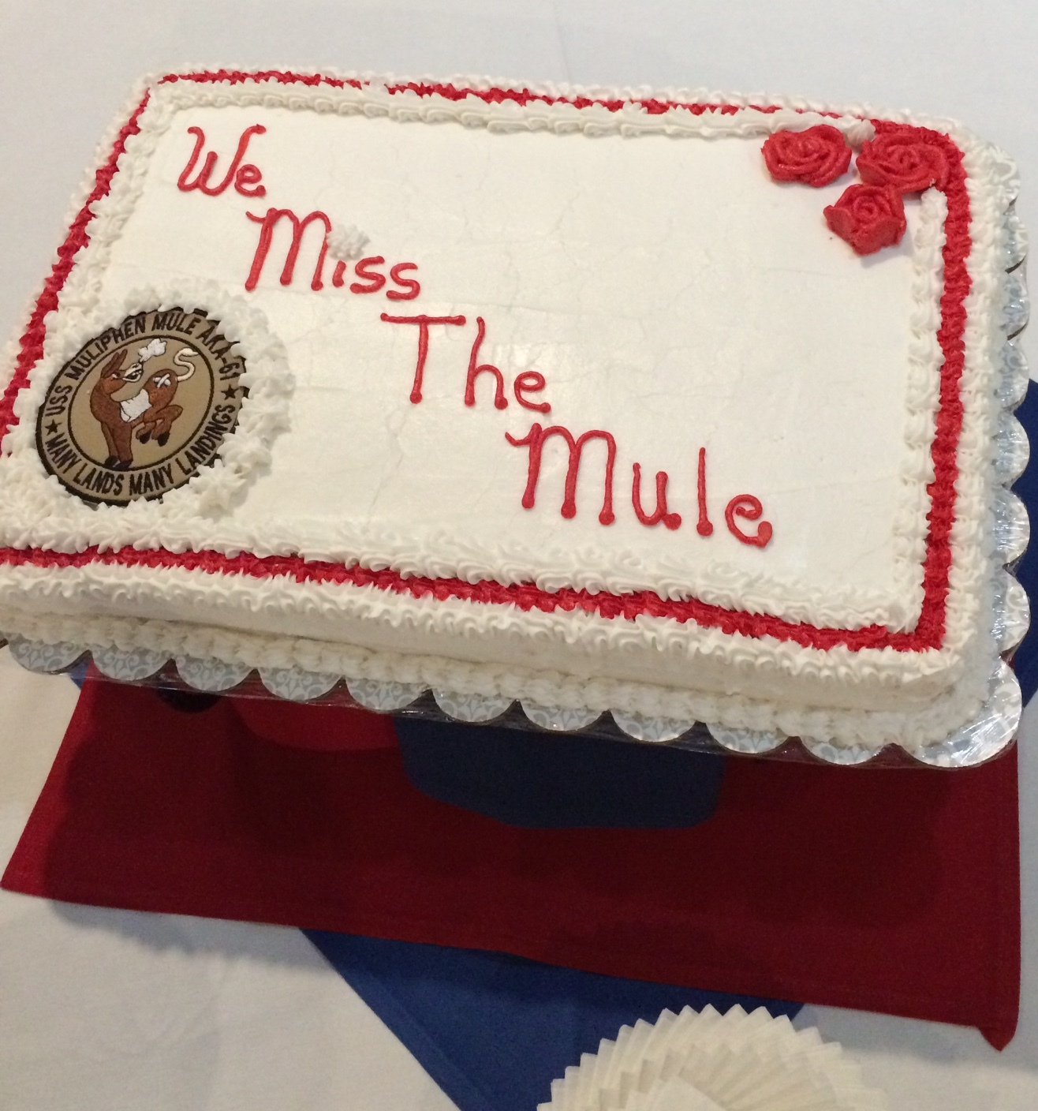
The hospitality room was a little crowed, but no one complained as we renewed old acquaintances. Checked out things to buy as the new Ship's Storekeeper Bob Casey (62) took over with much help from our retiring Storekeeper George Hollins (66). George has promised to keep coming to the reunions and helping man the shop in the hospitality room. We also had several very nice items donated to the "silent auction" one was a beautiful, USS Muliphen bed quilt, donated by David & Pat Means (51)..
Because the reunion was one day shorter, we didn't get as much "Hospitality" face time as we all wanted. The "Welcome Party" was fun with all the introductions and meeting "first" time attendees:
BT3 (55) Douglas & Jane Johnson
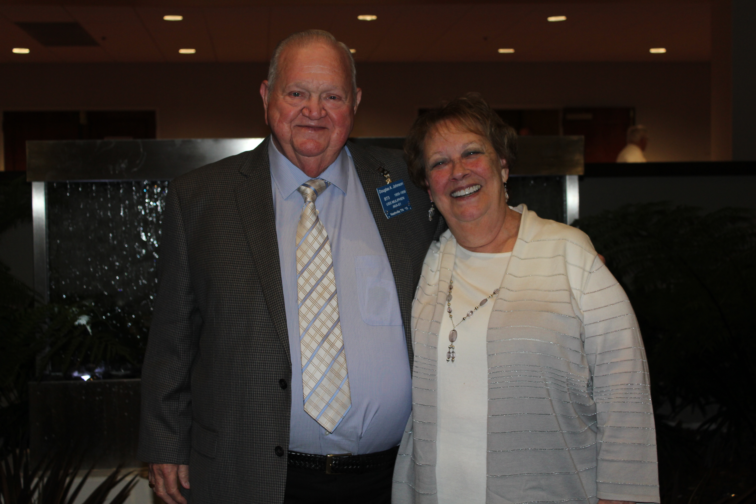
MM3 (59) Jack & Gerri White
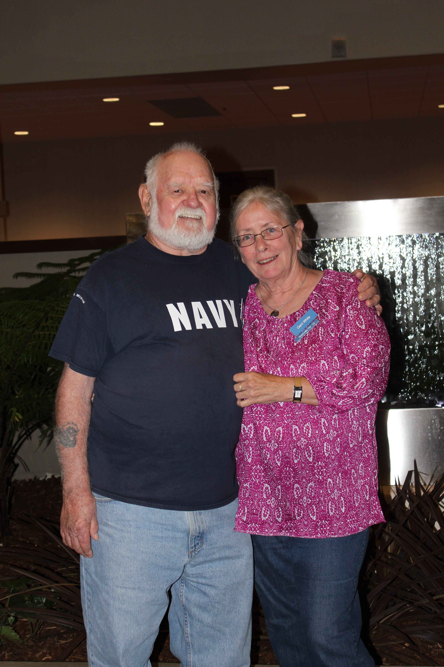

There was a City of Nashville bus tour with lunch included, Then back for a rest, followed by Social Hour and Photo's taken before the "Friday" banquet. Vice President Richard Markley (63) provided an award plaque that was given to retiring Storekeeper George Hollins (66).

Besides the 50/50 drawing, there was live Nashville entertainment with


singers Ryan and Bob Wotherspoon with Ryan's friend, Casey on the guitar. (I didn't get the musical talent in the family). On Saturday, there was a General Jackson Riverboat, luncheon, live music and comedy. Then later a soup & sandwich Pre-Grand Ole Opry snack. Then off to the Opry, with Reba McEntire headlining. After the show a nice desert back at the hotel. The Muliphen business meeting was held on Saturday and by a vote of hands (then later an online & telephone vote) it was decided to have a cruise for next years (21st) reunion. "Get your Passport ready."

Attending the 2015 Nashville Reunion

SM1 (61) Herman & Nancy Autry
Raeford, NC
MM2 (63) Alan & Laura Bieler
Medford, NY
EM3 (62) Robert Casey
St. Louis, MO with guest *
- Karen Robertson
SN (61) William Christoffersen
Holiday, FL
QM3 (62) David & Ruth Elder
Elizabeth City, NC
RM3 (59) John & Neva Ellas
Hilliard, OH
YN1 (66) George & Rachel Hollins
Bumpass, VA
BT3 (55) Douglas & Jane Johnson (1st time)
Edenton, NC
PN3 (63) Richard & Faith Markley
Millington, TN
EN3 (61) Edward & Louise Martin
Birch Run, MI
RD2 (63) Edward & Theresa McCaffrey
Vero Beach, FL with guest*
- Kevin & Kathy Murray
BT3 (57) David & Pat Means
Scott Depot, WV
EN3 (60) Vernon Miller
Weidman, MI with guest*
- Donna Earl
BMC (62) Thomas Robards
Williamsburg, VA
MM3 (63) Charles & Sharon Rothlingshofer
Westminster, MD
DC3 (63) James & Linda Sharp
Milford, OH
MM3 (59) Jack & Gerri White (1st time)
Inman, SC
YNSN (64 Gerald & Elizabeth Wotherspoon
Dover, FL with guest*
- David & Brenda Baines
- Robert & Margaret Wotherspoon

* Guest are a significant part of our reunions, they help us attend (we're getting older) they learn of our Muliphen escapades, the participate in conversations, reunion tours and add to the fun. Thank you to all our guest.
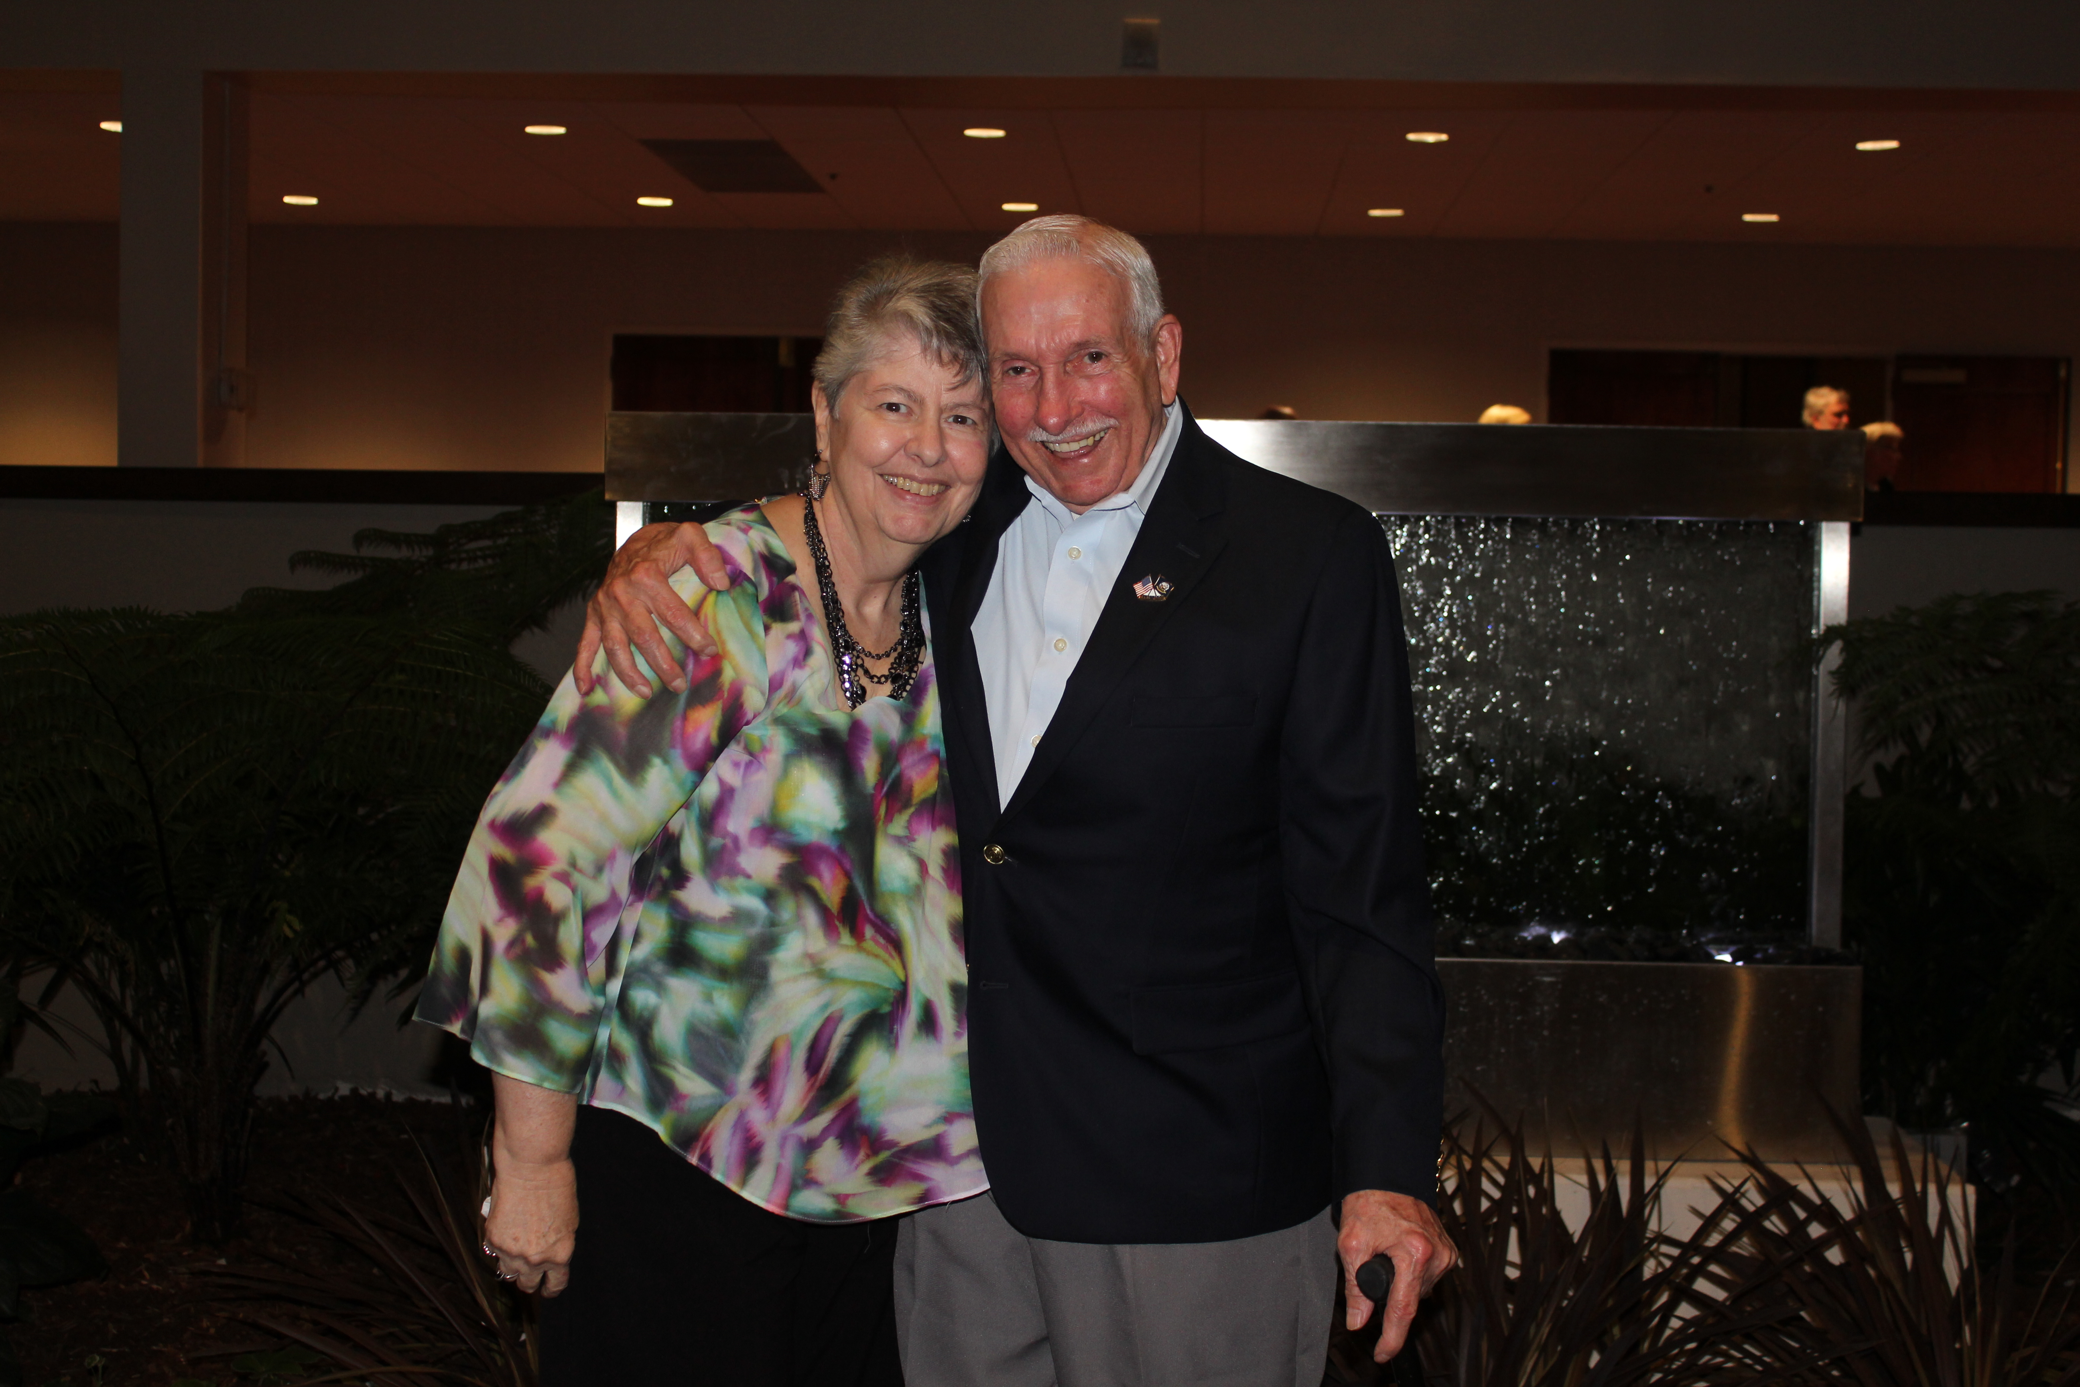
Storekeeper's Report

Retiring Storekeeper George Hollins (66) and Rachael provided a full accounting of his Store Treasury and Inventory to incoming Storekeeper Robert Casey (62), who then took custody of both the inventory and money. A Muliphen Store account will be opened in St. Louis. Items in the inventory will be photographed and advertised on the ship's website at: www.ussmuliphen.com and e-bay, payment for items will be through PayPal, managed by Karen Robertson, Bob's trusted friend.

Treasurers Report
Treasurer Linda Sharp, wife of shipmate James Sharp (63) provided the 2015 report as follows:

Beginning Balance: $5,936.89
Donations: $3,315.00
Expenses: $4545.64
Ending Balance: $4706.25

All monthly 5/3 bank statements available for review on request.

Chaplin's Log for 2014

After conducting the "Missing-man / White table ceremony, Chaplin Herman Autry (61) tolled the bell as President Gerald Wotherspoon (64) read the names.

- 1955 IC2c J. W. "Harry" Wilkins, Salem, FL, died 01/02/14
- 1950 EN2c Stanton R. "Skip" Price, Bridgewater, NJ died 01/07/14
- 1944 MM2c Edward George "Tim" O'Brien, Waikoloa, HI died 01/08/14
- 1944 S1c Joseph Martin Kreitzer, Carlisle, PA died 01/29/14
- 1945 YN3c Raymond Roth Evans, Ironton, OH died 02/06/14
- 1944 S1c Richard Louis Carles, North Baltimore, OH died 04/15/2014
- 1953 MR3c Aloysius V. "Al" Trejchel, Erie, PA died 04/19/14
- 1956 CAPT James "Jim" Hoge, Moundsville, WV died 06/02/14
- 1954 BT1 Eugene L. "Snuffy" Mansfield, Renfrew, PA died 07/02/14
- 1944 ENS John L. "Logan" Rogers, Sr. Spokane, WA died 08/11/2014
- 1944 S1c James Davidson, Toledo, OH died 08/26/14
- 1959 IC2c John Spencer, Louisville, KY died 09/17/14
- 1944 MM1c Lincoln Gustave Lauch, Montgomery, OH died 10/20/14
- 1969 LTjg Joseph Lee "Joe" Combs, Festus, MO died 10/20/14
- 1947 LT Harold Philip Deeley,Jr. Annandale, VA died 10/30/14
- 1956 HMC Bobbie Floyd Cook, Haines City, FL died 11/25/14
- 1958 RM2 Caleb L. Blanton, Jr. Coal City, IL died 12/09/14
- 1951 BT2 Joseph W. Michalski, Baltimore, MD died 12/13/14
- 1954 RD3 Donald W. Williams, Evansville, IN died 12/26/14

Past Reunions

2015 was our 20th Reunion. I've gathered the names of all the shipmates that have attended, here is a breakdown of the top 10 attendees:
- SM1 (61) Herman Autry = 18
- EN3 (61) Ed Martin = 16
- PN3 (63) Richard Markley = 15
- YN1 (66) George Hollins - 14
- BT3 (51) David Means = 13
- MM3 (49) Richard Schroeder = 13
- RM3 (59) John Ellas = 12
- EM3 (58) Dr. Fred Rogriguez = 12
- HM3 (64) Ron Wiant = 12
- EM3 (62) Robert Casey = 11
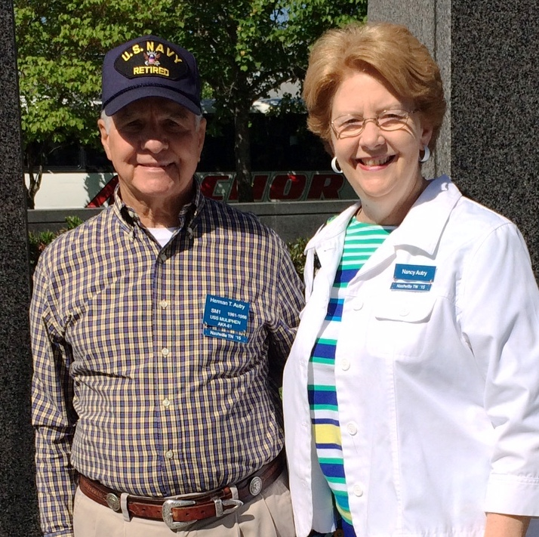
Wow Herman, I'm impressed 18 out of 20 !!!

Galley Officer comments:

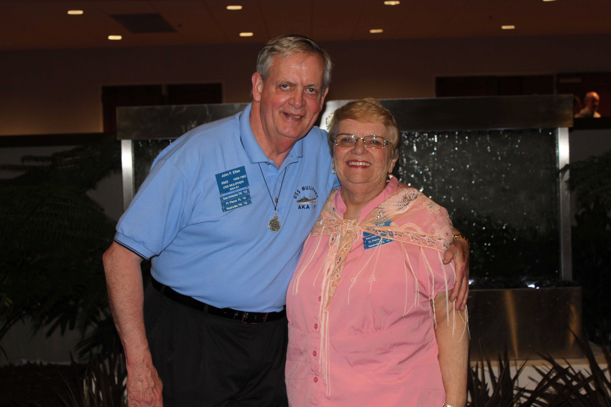
We've attended 12 of the Muliphen Reunions, missing just a few at the very beginning of our Association. It's been a "True Blessing", to revisit our past year's together, aboard our truly great Navy Ship, the U.S.S. Muliphen. Having fellowship with my Shipmates and Spouses, at interesting Tour location's, has added to our joy throughout our life. Losing shipmates each year has made this Reunion something special for us. The Nashville Reunion was truly a wonderful time of fellowship, enjoying the Music History of this remarkable area. Having some past health issues for myself and my wife, has always presented a challenge in our attendance. Following our Naval Reunion we were able to visit Memphis, TN and its many sights to relive. The early beginning of Rock & Roll/Elvis, The Sun Recording Studio, The Peabody Hotel/Duck Walk, The Pyramid/Bass Pro. Display, all of this added to our enjoyment of our Naval Reunion! On way home, visiting the farm of Famed Country Artist, Loretta Lynn was enjoyable. We even had breakfast @ the famous Loveless Cafe, enjoying the World's Tastiest Biscuits. We drove 800-900 miles but had a very good time, arriving home on Thursday morning. We're "Thankful" that we have a very good Leader @ the Helm of our vessel in, Jerry Wotherspoon!
God Bless All - John and Neva Ellas

Plank Owner's Log

Seaman 1st Class (s1c) Cyril H. Feldman (1944 Plank Owner) has a video taped interview posted on the internet by his Stepson Todd Pearl. (interesting to watch). Cy was 18 years old and a signalman on a Muliphen landing craft during the battle of Iwo Jima. On his 3rd trip to shore he met Photographer Joe Rosenthal, the now famous photographer of the flag raising on Mount Suribachi . The narration of this event by Cy is fascinating.
We had a total of 10 known living 1944 "Plank Owners", I had wood grain Plank Owners name tags made for each one.

- BM2 Cecil Earl Martin of Anderson, SC
- USMC/PFC Richard Neuharth of Lodi, CA
- S1c James Joseph Meehan of Lowell, MA
- S1c Robert J. Wright of Colorado Springs, CO
- MM3 George J. DeSpain of Fredericktown, MO
- S1c Joseph R. Keene of Jacksonville, FL
- MoMM2c Charles D. Mouton, Jr. of Sulphur, LA
- MSKC Lawrence Boyer of San Diego, CA
- ENCS George Brown, Jr. of Rocky Mount, NC
- S1c Cyril H. Feldman of West Bloomfield, MI

2016 Muliphen Reunion

Our 21st year reunion will be a sea Cruise. Based on the request of a majority of Muliphen Shipmates. (see the voting on the Muliphen website message board at www.ussmuliphen.com)

Either Caribbean or Mexico (T.B.A.) Unlike our last "cancelled" cruise reunion. There will be no cancellation, unless it effects the actual ship we depart on. We had approx 60 people booked for the last one and at least 1/2 would have continued, had I not cancelled it. For the 2016 cruise reunion, we encourage you bringing family and friends. It will be a cheap way to make it a family & friends reunion for yourself. The more the merrier. Again, I will make special plans for the Muliphen reunion on the ship.

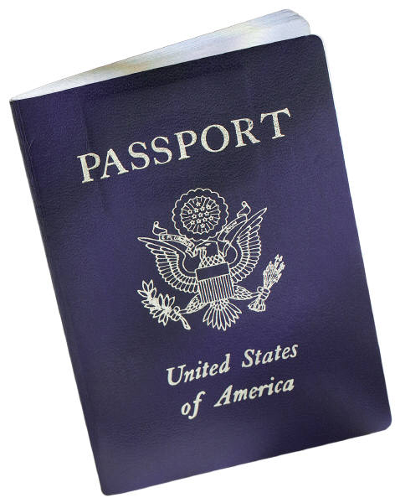
The rates, quoted by the cruise lines, will be at the cheapest rate for lower inside cabin. You can use your previous cruising points and you can upgrade to a bigger outside/suite for an additional fee. We will have both "Muliphen" time, "Family & Friends" time. You can participate in any shipboard or land events or none at all. The price that I get quoted will be locked in for a designated period of time. When that time expires and there is still room on the ship, you can still book with the same booking number (the number will be given at a later date). The late booking may be charged a slightly higher fee. We will have a full refund cancellation date assigned. If you book using a "super-saver" and not use the Muliphen booking number, you could be subject to "no-refund".

NOTICE... NOTICE...NOTICE
Start now, check your Passports and update as necessary. Note: it's true you don't need a passport for the Caribbean, but if for some reason you miss the ship's movement or need to fly home in a hurry. You MUST have a Passport with you. Otherwise, it gets complicated and time consuming. Plus, your stuck in port waiting for Embassy clearance or having someone FedEx your passport to you from home..
USS Muliphen Newsletter
The USS Muliphen Newsletter is published by:
The USS Muliphen Reunion Association, Inc.
1920 Raven Manor Dr.
Dover, FL 33527
Phone: 813-685-9477
Back issues maybe viewed online at
www.ussmuliphen.com
The USS Muliphen Reunion Assoc. Inc. is a IRS
non-profit 501(c)19 veterans' organization. Incorporated in Delaware/Florida. and Donations to the Association qualify as Charitable Contributions for the IRS, Income Tax purpose.
Members of the Executive Board
President: Gerald Wotherspoon 64'
Vice President: Richard Markley 63'
Secretary: Louise Martin
Treasurer: Linda Sharp
Storekeeper: Robert Casey 62'
Galley Officer: John Ellas 59'
Chaplain: Herman Autry 61'
Historian: Dr. Fred Rodriguez 59'
Membership Officer: Joan Wiant
(c) 2015 The USS Muliphen Assoc. Inc.

