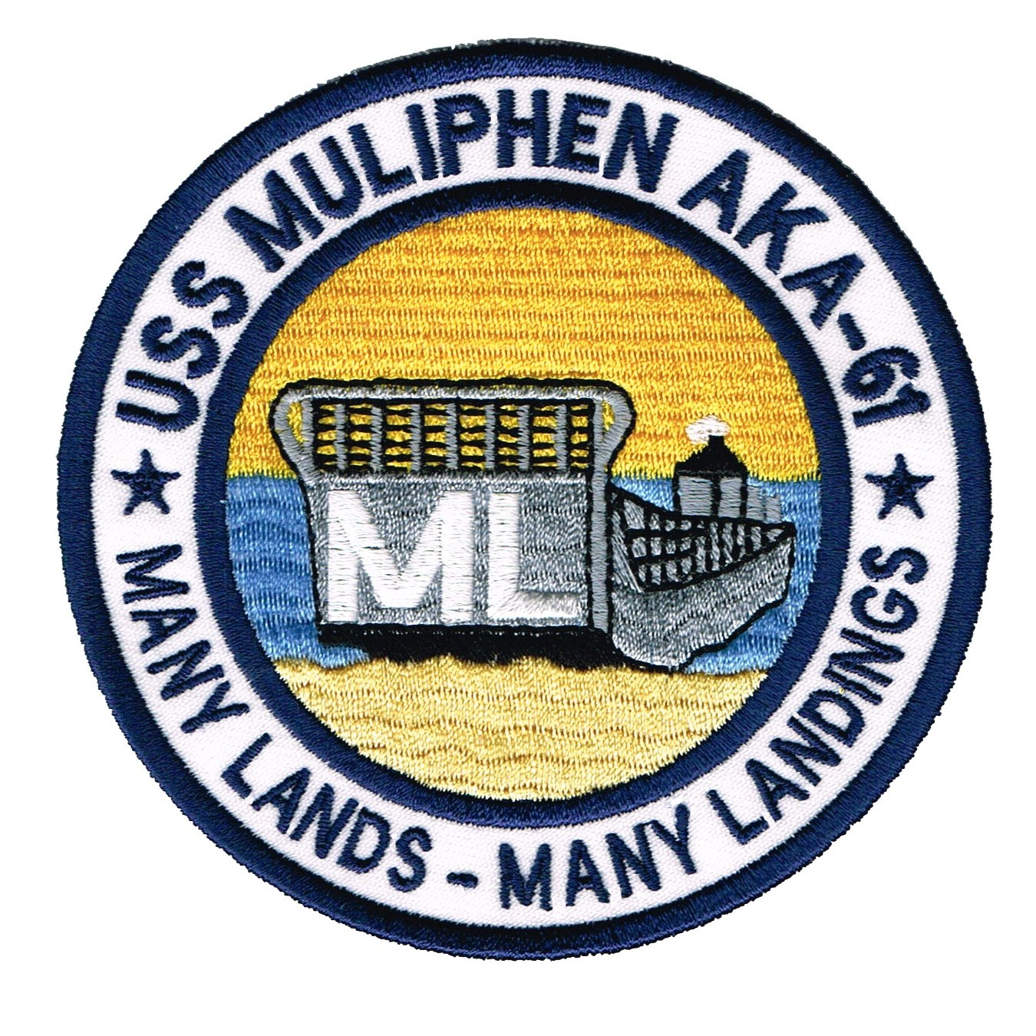
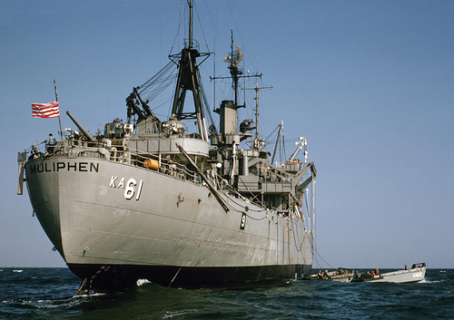
USS Muliphen AKA-61
April 2013 USS Muliphen Association Newsletter


Greetings from the Helm.
During the last few months, several key Muliphen events have taken place. The museum has been updated with Muliphen artifacts and paraphernalia (more later). The 2013 reunion has been changed. On a personal note, my computer crash has set my Muliphen research back.

My wife and I are avid cruisers with Carnival and Holland cruise lines. It is unfortunate the quality control of the cruise lines have been neglected. What was once an exciting event, taking a 4 or 5 day cruise has turned into a nightmare of worry. It's obvious that if the cruise industry doesn't respond to upgrade and maintain their vessels, they will succumb to bankruptcy. As your President, along with several other shipmate cruisers, we will monitor the cruise industries' progress. Hopefully, the Muliphen will have the opportunity for a future cruise reunion.

On to the 2013 reunion. I know that (Spring) has always been the designated reunion time. It appears that 15 or 20 shipmates attending the reunion, does not make a valid reason to maintain Spring reunions. We don't have the buying power with 15 or 20 shipmates (30 to 40 in attendance) that we would have with 100 plus. It is for that reason, we have joined the USS Rankin reunions. Co-reunion or (joint-reunion) have better buying power. The Rankin is a much larger group and therefore dictate the time of year. I've been working very close with the Rankin's leader "Skip" Sander. We've started ironing out the equity of co-reunion benefits. Here is an example, we will each have a hospitality room allowing the independence of each group. The tours, banquets and room rates will all be based on the total number of attendees from both groups. As a side note, the banquet held at the joint-reunion in Charleston, SC went very well, (bigger 50/50 pot) and a diversity of many new friends. (See the attached Hotel registration form to book the 2013 San Antonio reunion). Registration for the tours, etc. will be forthcoming in July 2013.

Transparency of leadership:

Unlike the existing U.S. government official, spouting "transparency", I live it. I will answer all questions from shipmates. Just to make it clear here are a few examples of question (yet to be asked).

- Question: Why do I want to be the Muliphen President?
Answer: I could answer with a clean patriotic type answer, but I'll go a little deeper. I want this group to survive, get together, socialize, be happy to see old friends, let children and grandchildren know who we were. The reason for the museum, the reason to invite family to the reunions.
- Question: What do I get out of it?
Answer: The easy answer is satisfaction from the results of the above question. In addition, I do get some benefits. At the reunion, I often get a free or upgraded room. I get invited to "FAM" trips. "FAMiliarization" trips are often invitations by a local CVB (County Visitors Bureau) to a city, all expense paid. Free room, food, tours and travel. During the FAM trips, I decide if the city has potential for a Muliphen reunion. I also see which hotel, tour, etc. meet the Muliphen needs. Since I am retired and have time, this is one of the best benefits of the leadership. I also share my FAM trips with our Executive Board, giving them the opportunity to visit and decide on new reunion locations. So far, none have taken me up on this opportunity. I've been on four, Chattanooga, TN, St. Pete Beach, FL, Williamsburg, VA and Baton Rouge, LA.
- Question: What are the Muliphen operating expenses?
Answer: Newsletter preparations and mail out, correspondence with donors, reunion supplies, mailings, hospitality room upkeep, misc. non-attendee expenses for the reunion and sometimes small reunion gifts. Museum item preparations. Website charges.
- Question: Are you reimbursed for purchases?
Answer: Yes, for financial out of the pocket cost, but not for time. The same with our other Executive Board members. Especially our Storekeeper and Treasurer. I try to make sure those helping the association have no or little out of pocket personal expenses.

If you ask, I will answer!

Gerald "Jerry" Wotherspoon, (1964-1965) President USS Muliphen Reunion Assoc.



Obituary 2012

Walter D. Schreck 1/22/12
Norbert H. Shinsky 1/23/12
Ronald Lee Wiant 2/24/12
Jack Pine Trees 3/19/12
Carroll Crimmin 3/28/12
Edward Stanlake 5/11/12
Lavern C. Zilla 6/12/12
Robert G. Johnston 7/23/12
Warren Paul Cantrell 9/7/12
Thomas Griffith Keesee 10/5/12
Roger L. McClellan 10/9/12
William R. Mann 10/30/12
Waring Lewis Worsham, Sr. 11/7/12

Please provide me with updated information on Crewmembers that have passed away. Our Association Members Officer: (Ms. Joan Wiant) will send a bereavement card on behalf of the association.

(The 1st Muliphen Reunion Group 1996) (1964 Crew Photo, I'm there in the white Uniform)
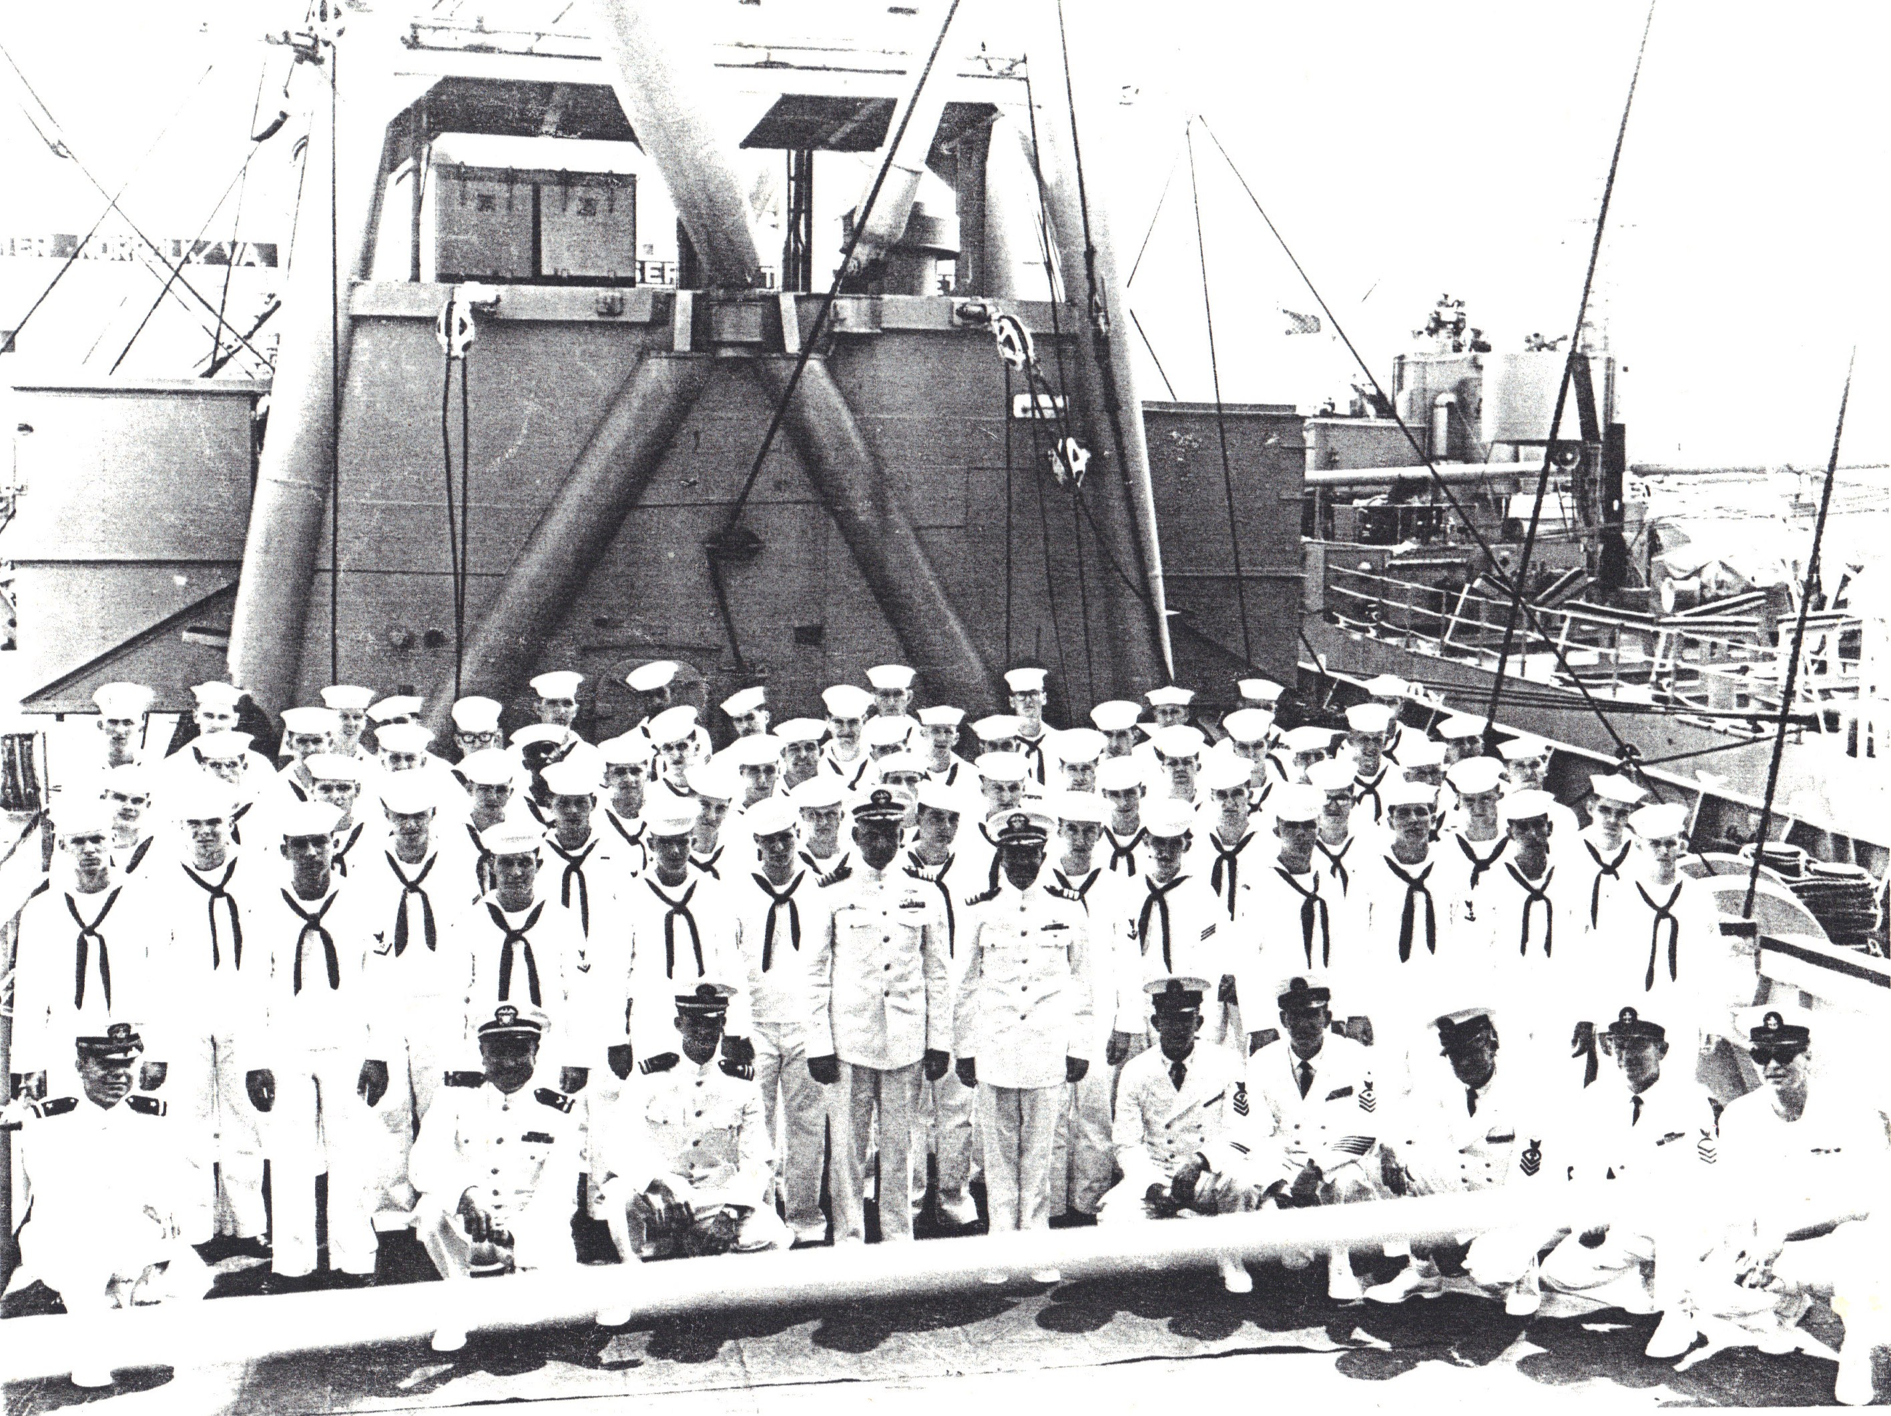
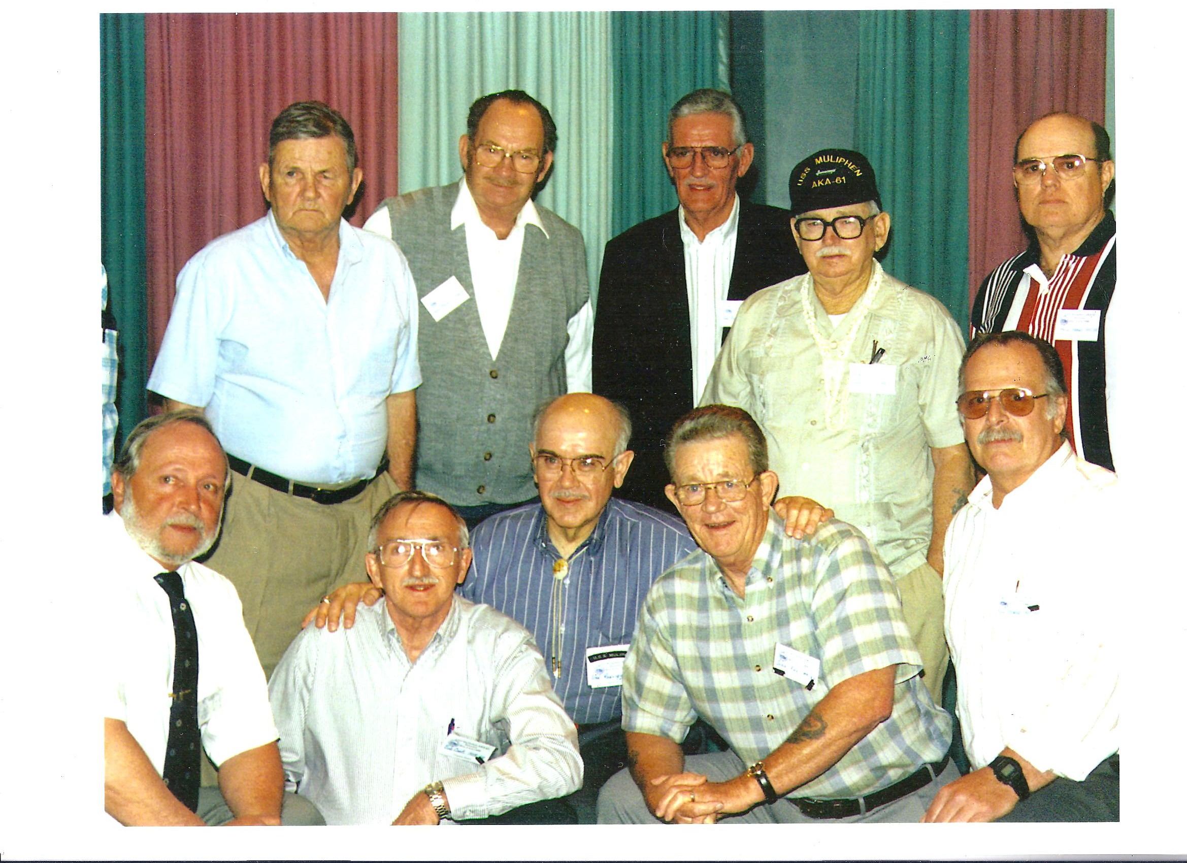


Ye Ole Navy Bean Soup
YIELD: 6 1/4 Gallons or 100 portions, each portion: 1 cup
INGREDIENTS | WEIGHTS | MEASURES | PORTIONS | METHOD
Beans, white, dry | 6 lbs. | 3 1/2 qt. | -- | 1. Pick over and wash beans.
Ham stock  Ham bones |  | 7 gal.  8 bones | -- | 2. Add ham stock and ham bones. Heat to boiling point; cover and simmer 2-3 hours or until beans are tender. If necessary, add hot water.  3. Remove ham bones.
Carrots, shredded  Onions, finely chopped  Pepper | 1 lb.  2 lbs. | 2 3/4 cups  4 1/2 cups  2 tsp. | -- | 4. Add carrots, onions, and pepper. Simmer for 30 minutes.
Flour, hard wheat, sifted  Water, cold | 1/2 lb. | 2 cups  3/4 qt. | -- | 5. Blend flour and water to a smooth paste. Stir into soup, and cook 10 minutes longer.
NOTE:
1. If beans are old, soak 3 to 4 hours prior to cooking.
2. Add salt and additional pepper if desired.
VARIATION:
Old Fashioned Navy Bean Soup: Add one No. 10 can of tomatoes in Step 4.

Contributions and Donations
According to our Treasurer, Linda Sharp, we have, as of this Newsletter $6,376.55 and that does not include, the Newsletter preparations and mailings. Our account is with the Fifth/Third Bank and monitored by the President, Vice President and Treasurer. For those that have already made their 2013 donation, "Thank you very much." Your contributions are sincerely appreciated and will be put to good use. A reminder to all those who contribute, we are a 501(c)19 non-profit military organization and your donation is tax deductable.
- Please use the attached (self addressed) envelope for 2013 Donation. Thank You.

2013 Reunion Plans

Our 2013 reunion will be our Eighteenth annual reunion. We will join with the USS Rankin AKA-103, much like we did in Charleston, SC during our Sixteenth reunion in 2011. At the Charleston reunion we had over 100 attendees participating in all planned events.
My research of former Muliphen shipmates has yielded over 1500 names. Of which around 200 have valid email addresses, over 400 have valid mailing addresses and the remaining 1100 have yet to identified by address or have passed on. I want to make it clear to our shipmates, the reunion is more than just old guys setting around talking about their Glory Days. We include spouses and children, grand children and other family members and friends. The tours are learning experiences and fun at the same time. We have found families come together and take this time to recognize the accomplishments of their Father or Grand-dad or good friend.
The Reunion will be in San Antonio, TX, in October from Thursday the 10th through Sunday the 13th. 2013. It will be held at the beautiful Crowne Plaza Riverwalk Hotel located on the downtown River Walk. The attached flyer has the booking code of RQZ and the rates are locked in at $119.00 per day, that includes buffet breakfast. We've negotiated a $10 per. day (cheap) parking rate. All these rates are good for three days before and after the reunion for those that want to come early or stick around.
The Reunion itinerary has been set, and rates for tours are still being negotiated. The attached flyer will give you a good idea of our fun filled reunion weekend.
Room reservation is available now, just call the number on the flyer: T.B.A. and tell them it's for the Muliphen / Rankin reunion and the Group code is: RQZ.
We have started our search for the 2014 reunion. Suggestions have been Tampa, FL, Fort Pierce, FL, Baton Rouge, LA, Nashville, TN, Virginia Beach, VA, Chicago, IL and even Long Beach, CA. Remember the power of selection is in the power of attendance.

Important notice! Please send me updated information. Married, Divorced, Deceased, Email, New Address, Phone.
If you know any of the shipmates listed on the website without "City, State or Email" listed listed after their name, please forward their information to me at: President@ussmuliphen.com. We also respect the "Do Not Contact" request by some former shipmates.

USS Muliphen News
The USS Muliphen news is published by:
The USS Muliphen Reunion Assoc.
2409 Devonwoode Place.
Seffner, FL 33584
813-685-9477
www.ussmuliphen.com
Back issues can be viewed online at www.ussmuliphen.com
The USS Muliphen Reunion Association is a non-profit 501(c)19 veterans' organization. Incorporated in Delaware. Donations to the Association qualify as charitable contributions for Federal Income Tax purpose.
Members of the Executive Board

President: Gerald Wotherspoon
Vice President: Richard Markley
Secretary: Louise Martin
Treasure: Linda Sharp
Storekeeper: George Hollins
Galley Officer: John Ellas
Chaplain: Herman Autry
Historian: Fred Rodriguez
Members Officer: Joan Wiant

© 2013 The USS Muliphen Assoc.

